## (15 points.) CSPs

You are in charge of scheduling for computer science classes that meet Mondays, Wednesdays and Fridays. There are 5 classes that meet on these days and 3 professors who will be teaching these classes. You are constrained by the fact that each professor can only teach one class at a time.

The classes are:

* + Class 1 - Intro to Programming: meets from 8:00-9:00am
  + Class 2 - Intro to Artificial Intelligence: meets from 8:30-9:30am
  + Class 3 - Natural Language Processing: meets from 9:00-10:00am
  + Class 4 - Computer Vision: meets from 9:00-10:00am
  + Class 5 - Machine Learning: meets from 9:30-10:30am

The professors are:

* + Professor A, who is available to teach Classes 3 and 4.
  + Professor B, who is available to teach Classes 2, 3, 4, and 5.
  + Professor C, who is available to teach Classes 1, 2, 3, 4, 5.

1. **(4 pts):** Formulate this problem as a CSP problem in which there is one variable per class, stating the domains, and constraints. Constraints should be specified formally and precisely, but may be implicit rather than explicit.

*V ariables Domains*(*orunaryconstraints*) *C*1 *C*

*C*2 *B, C*

*C*3 *A, B, C*

*C*4 *A, B, C*

*C*5 *B, C*

Constraints:

*C*1 *NOT EQUAL TO*  *C*2

*C*2 *NOT EQUAL TO*  *C*3

*C*3 *NOT EQUAL TO*  *C*4

*C*4 *NOT EQUAL TO*  *C*5

*C*2 *NOT EQUAL TO*  *C*4

*C*3 *NOT EQUAL TO*  *C*5

1. **(2 pts):** Draw the constraint graph associated with your CSP.

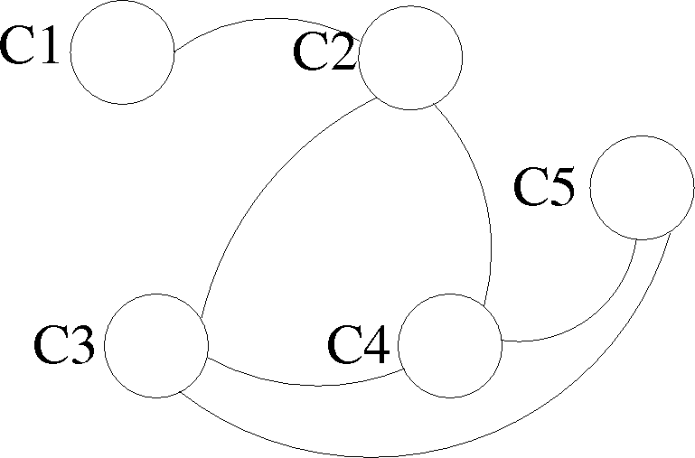

1. **(4 pts):** Show the domains of the variables after running arc-consistency on this initial graph (after having already enforced any unary constraints).

*V ariable Domain C*1 *C*

*C*2 *B*

*C*3 *A, C*

*C*4 *A, C*

*C*5 *B, C*

Note that C5 cannot possibly be C, but arc consistency does not rule it out.

1. **(1 pt):** Give one solution to this CSP.

C1 = C, C2 = B, C3 = C, C4 = A, C5 = B. One other solution is possible (where C3 and C4 are switched).